**Content Portfolio Optimization - Entertainment Sector**

Pooja Joshi & E.Code [E25007]

# Overview :

# The report outlines the analysis and optimization process for the content portfolio in the entertainment sector. This includes data processing, sentiment analysis, and performance evaluation to inform decision-making.

# Objective:

To optimize the content portfolio based on valuation, popularity, and sentiment analysis

# Assigned Task(s) :

·Conduct a comprehensive analysis of the provided dataset.

· Implement sentiment analysis on movie reviews.

· Identify an optimized portfolio based on defined metrics.

# Task Details :

#### Task 1: Data Analysis and Optimization

* **Status:** Completed
* **Details:**
  + Loaded the dataset and performed initial explorations.
  + Calculated cost and derived metrics for portfolio optimization.
  + Conducted sentiment analysis using the VADER lexicon.

#### Task 2: Sentiment Score Integration

* **Status:** Completed
* **Details:**
  + Assigned sentiment scores to the optimized_portfolio DataFrame.
  + Debugged KeyErrors to ensure proper integration of sentiment score columns.
  + Generated compound, positive, negative, and neutral sentiment scores for each movie.

#### Task 3: Visualization and Correlation Analysis

* **Status:** In Progress
* **Details:**
  + Created visualizations for the sentiment scores and portfolio metrics.
  + Conducted a correlation analysis between valuation, popularity, attendance count, and sentiment scores.
  + Prepared a preliminary report for stakeholders, summarizing findings and insights.

# 

# 

# 

# 

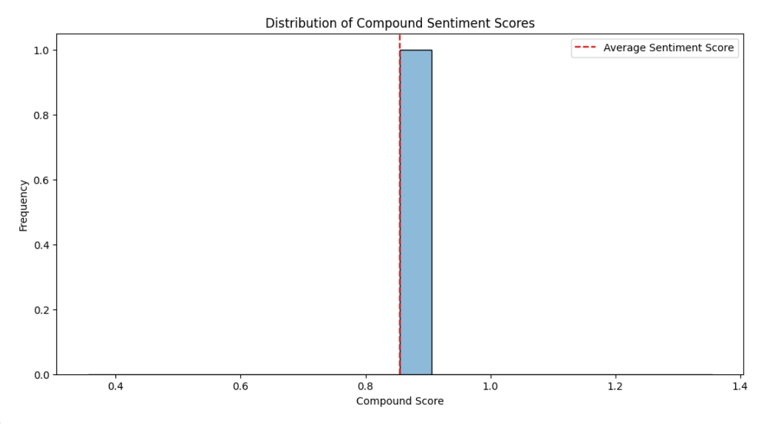

**Progress :**

· **Accomplishments:**

* Successfully processed the data and performed sentiment analysis.
* Identified an optimized content portfolio.
* Integrated sentiment scores into the portfolio DataFrame.

· **Metrics:**

* Total Valuation: 6657.46
* Total Cost: 1022.43

# Challenges and Solutions :

· **Challenges Faced:**

* Encountered KeyError during sentiment score retrieval.

· **Solutions Implemented:**

* Adjusted the DataFrame to ensure correct sentiment score assignment.

# Next Steps :

· **Upcoming Tasks:**

* Finalize the sentiment analysis and visualizations for the report.
* Conduct further evaluations and refine the models used in the analysis.

· **Goals:**

* Prepare a comprehensive report on the findings and recommendations for stakeholders.

# Conclusion :

**Summary**: The content portfolio has been optimized based on valuation, popularity, and sentiment analysis. The process revealed significant insights for strategic decision-making.

# **Acknowledgments**: Thank the audience for their time and attention.

# Instructions:

1. Use Google Docs. Single Column
2. TNR stands for Times New Roman: B - Bold
3. Use images as required with proper references
4. Use charts, tables as per your requirement.
5. Number of Pages: 2 to 8 for each task report.